To view IP address of GUVI.IN:

Using nslookup command:

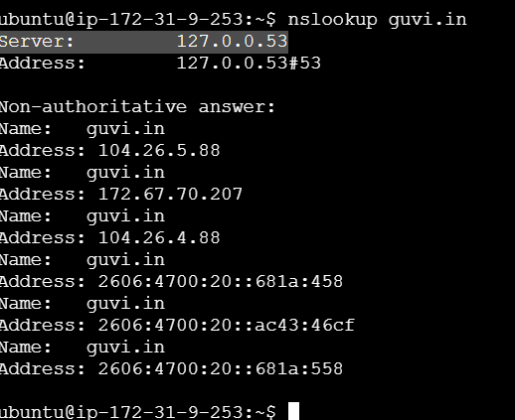

Using dig command:

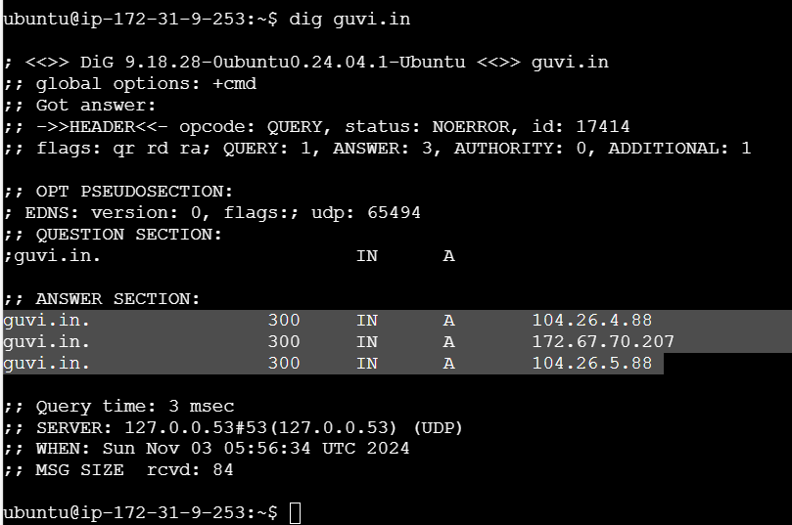

To view CPU & Memory usage:

Using htop command:

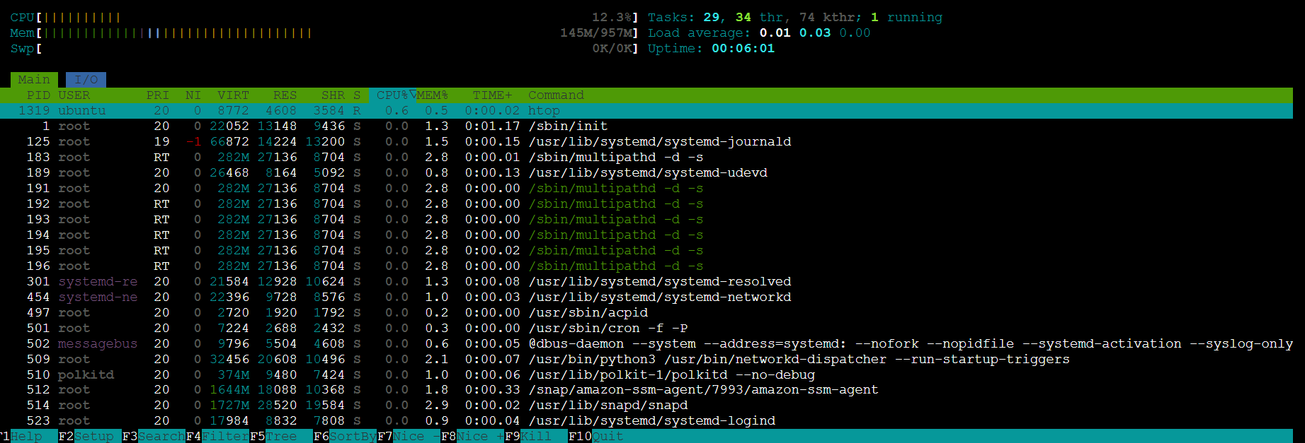

To view nodes connection:

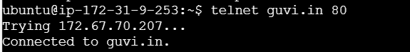

To check whether the port is open or not:

